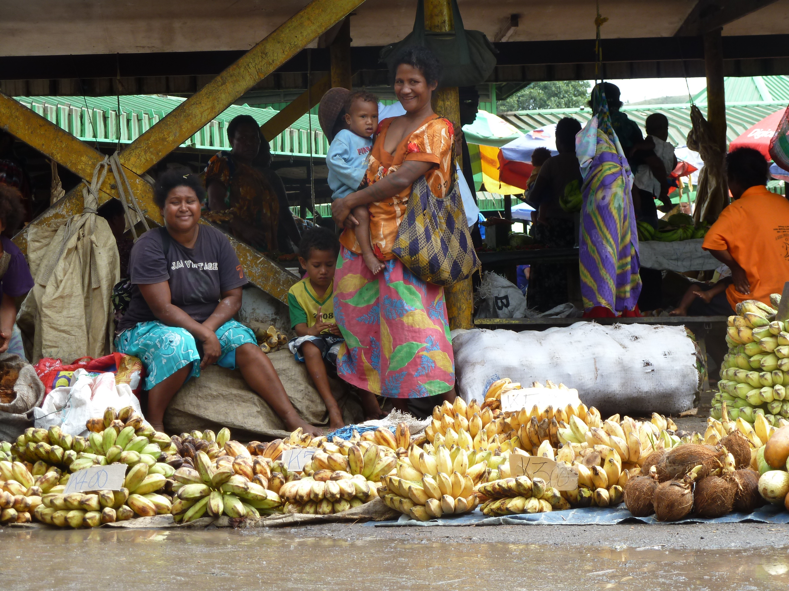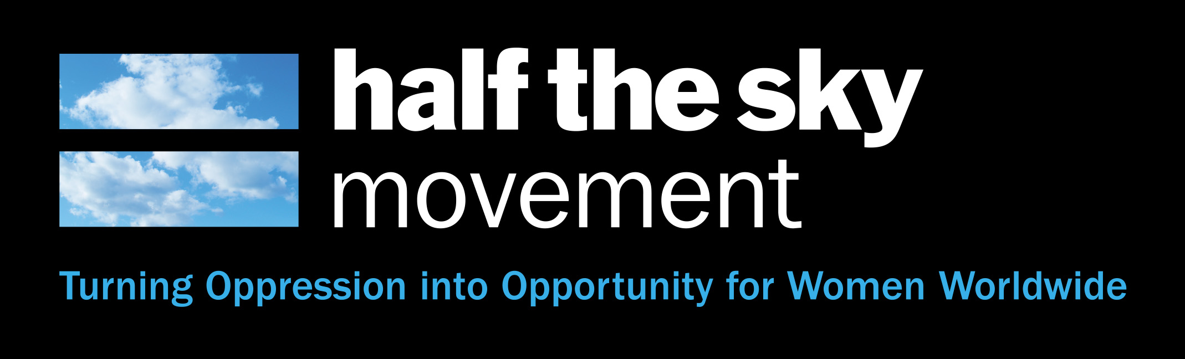

Date: 12th March 2013

Venue: Dendy Cinema, Opera Quays

Contact: IWD2@...

For further info go to: www.unwomen.org.au

**Money raised goes to critical services for women in PNG**

**A NIGHT OUT TO BE REMEMBERED...**

**Showcasing the award winning New York Times Documentary ‘Half the Sky’ and a prominent selection of Inspiring speakers.**

**Proudly presented by the Sydney Chapter of Young UN Women Australia in celebration of International Women's Day!**

***tOGETHER***

***HOLDING UP the sky***

*eNGAGE. INSPIRE. EMPOWER*